# Action Batch

Choose Action Batch -> Batchsettings

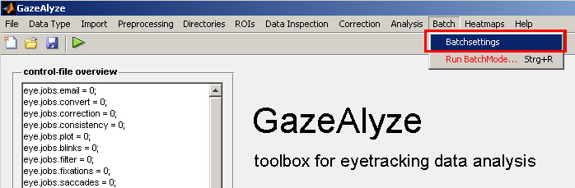

The following window will appear:

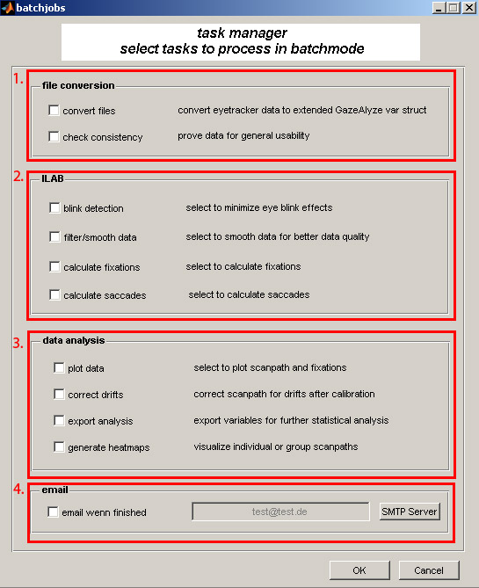

You can select what jobs to run, while this is the first run you have to do 1-3 if you wish the full package…

1. File conversion raw, logfile conversion & check if any files are broken
2. ILAB analysis, blink detection, calculation of fixations and so on...
3. Data analysis, export, plotting, generation of heatmaps
4. Optional: Send email, it can take some time to do the work, check this if you want to get an email when it’s done

After choosing what shall be done, it has to be done. Choose Batch -> Run BatchMode

